SIMATS ENGINEERING

ASSESSMENT TOOL 2

COURSE NAME: OBJECT ORIENTED ANALYSIS AND DESIGN COURSE CODE: CSA1110

COURSE OUTCOME COVERED

CO5: Analyze object-oriented software using quality assurance and usability testing Techniques (BL4, BL5)
Assessment Tool Weightage: 25%

QUESTIONS: 05 Total Marks:25

Annexure A

Error Analysis Task

Code of Conduct:

I Bheeshma L / 192511182 certify that this submission is my original work and that I have adhered to the guidelines specified for this assessment.
I understand that any violation of academic integrity rules will result in disciplinary action.

Signature of the student:
SARANRAJ G

RUBRICS FOR CALCULATION:

Error Analysis Task

Criteria | Weightag e | Level 4 – Exemplary | Level 3 – Proficient | Level 2 – Developing | Level 1 – Beginning
Error Identification | 20% | Accurately identifies all errors with clear understanding of  issues | Identifies most errors with minor  omissions | Identifies limited  errors; some are missed | Fails to identify key errors
Root Cause Analysis | 30% | Clearly explains underlying causes with strong technical  reasoning | Explains causes with moderate  clarity | Partial  explanation; weak reasoning | Unable to  identify causes of errors
Correction & Justification | 25% | Provides correct solutions with strong justification and logic | Provides correct corrections with some  justification | Corrections are partially correct or weakly  justified | Incorrect or no corrections provided
Application of Concepts | 15% | Effectively applies relevant concepts to analyze and resolve  errors | Applies concepts with minor errors | Limited application; requires  guidance | Unable to apply concepts
Clarity & Presentation | 10% | Presents analysis clearly, logically, and systematically | Generally clear with minor issues | Lacks clarity or proper structure | Poor presentation and difficult to understand

Annexure A
Error Analysis Task

Q1. Scenario: Online Banking System

Modules:
User Login, Fund Transfer, Account Verification

Question:

Write pseudocode for a quality assurance testing process that validates secure user authentication and fund transfer operations. Include input validation, transaction verification, exception handling, and test result logging.

Q2. Scenario: E-Commerce Shopping Platform

Features:
Product Search, Shopping Cart, Payment Gateway

Question:

Design pseudocode for a usability testing evaluation that measures customer interaction efficiency, including product search time, checkout completion time, and navigation complexity. Explain how the algorithm collects and analyzes user behavior data.

Q3. Scenario: Hospital Management System

Modules:
Patient Registration, Appointment Scheduling, Medical Records

Question:

Write pseudocode to generate and execute test cases for appointment scheduling functionality. Include validation of doctor availability, appointment conflicts, patient information accuracy, and system responses to invalid requests.

Q4. Scenario: Airline Reservation System

Modules:
Passenger Registration, Flight Booking, Seat Allocation

Question:

Develop pseudocode for a constraint-based testing approach where booking requests must satisfy conditions such as valid passenger information, seat availability, and payment confirmation. Show how invalid booking scenarios are detected and handled.

Q5. Scenario: Smart Library Management System

Features:
Book Search, Book Reservation, Borrow/Return Services

Question:

Write pseudocode for integrating quality assurance and usability testing where the system evaluates both functional correctness (reservation and borrowing operations) and user experience factors such as response time, ease of navigation, and accessibility.

Q1. Online Banking System
Modules / Features: User Login, Fund Transfer, Account Verification
Write pseudocode for a quality assurance testing process that validates secure user authentication and fund transfer operations. Include input validation, transaction verification, exception handling, and test result logging.

Pseudocode
BEGIN QA_Test_OnlineBanking

// ---- MODULE 1: User Login / Authentication ----FUNCTION testUserLogin(username, password):

TRY
IF username IS EMPTY OR password IS EMPTY THEN
RAISE InputValidationException("Credentials cannot be empty") END IF
IF NOT matchesPattern(username, VALID_USERNAME_REGEX) THEN RAISE InputValidationException("Invalid username format")

END IF

storedHash = DB.getPasswordHash(username) IF storedHash IS NULL THEN
RAISE AuthenticationException("User not found") END IF

IF hash(password) != storedHash THEN
attemptCount = incrementFailedAttempts(username)
IF attemptCount >= MAX_ATTEMPTS THEN lockAccount(username)
RAISE AccountLockedException("Account locked after repeated failures") END IF
RAISE AuthenticationException("Invalid credentials") END IF

sessionToken = generateSecureToken(username) logTestResult("Login", username, "PASS", currentTimestamp()) RETURN sessionToken

CATCH InputValidationException AS e
logTestResult("Login", username, "FAIL - " + e.message, currentTimestamp()) RETURN NULL
CATCH AuthenticationException AS e
logTestResult("Login", username, "FAIL - " + e.message, currentTimestamp()) RETURN NULL
CATCH AccountLockedException AS e
logTestResult("Login", username, "FAIL - " + e.message, currentTimestamp()) RETURN NULL

END TRY END FUNCTION

// ---- MODULE 2: Account Verification ----
FUNCTION testAccountVerification(sessionToken, accountId): TRY
IF NOT isValidSession(sessionToken) THEN
RAISE SessionException("Invalid or expired session") END IF
account = DB.getAccount(accountId)
IF account IS NULL OR account.status != "ACTIVE" THEN
RAISE AccountVerificationException("Account inactive or not found") END IF
logTestResult("AccountVerification", accountId, "PASS", currentTimestamp()) RETURN account
CATCH SessionException, AccountVerificationException AS e logTestResult("AccountVerification", accountId, "FAIL - " + e.message,
currentTimestamp())

RETURN NULL END TRY
END FUNCTION

// ---- MODULE 3: Fund Transfer ----
FUNCTION testFundTransfer(sessionToken, fromAcc, toAcc, amount): TRY
account = testAccountVerification(sessionToken, fromAcc) IF account IS NULL THEN
RAISE TransferException("Source account verification failed") END IF
IF amount <= 0 THEN
RAISE InputValidationException("Transfer amount must be positive") END IF
IF account.balance < amount THEN
RAISE InsufficientFundsException("Balance too low for transfer") END IF
IF DB.getAccount(toAcc) IS NULL THEN
RAISE InputValidationException("Destination account does not exist") END IF

BEGIN_TRANSACTION
debit(fromAcc, amount) credit(toAcc, amount)
COMMIT_TRANSACTION

logTestResult("FundTransfer", fromAcc + "->" + toAcc, "PASS", currentTimestamp())

RETURN "SUCCESS"

CATCH InsufficientFundsException, InputValidationException, TransferException AS
e
ROLLBACK_TRANSACTION
logTestResult("FundTransfer", fromAcc + "->" + toAcc, "FAIL - " + e.message,
currentTimestamp())

RETURN "FAILURE" END TRY
END FUNCTION

// ---- Driver: run test suite and summarize ----FUNCTION runTestSuite(testCases):
FOR EACH tc IN testCases DO result = executeTestCase(tc) appendToTestReport(result)

END FOR
generateSummaryReport() END FUNCTION

END QA_Test_OnlineBanking

Process Flow Diagram
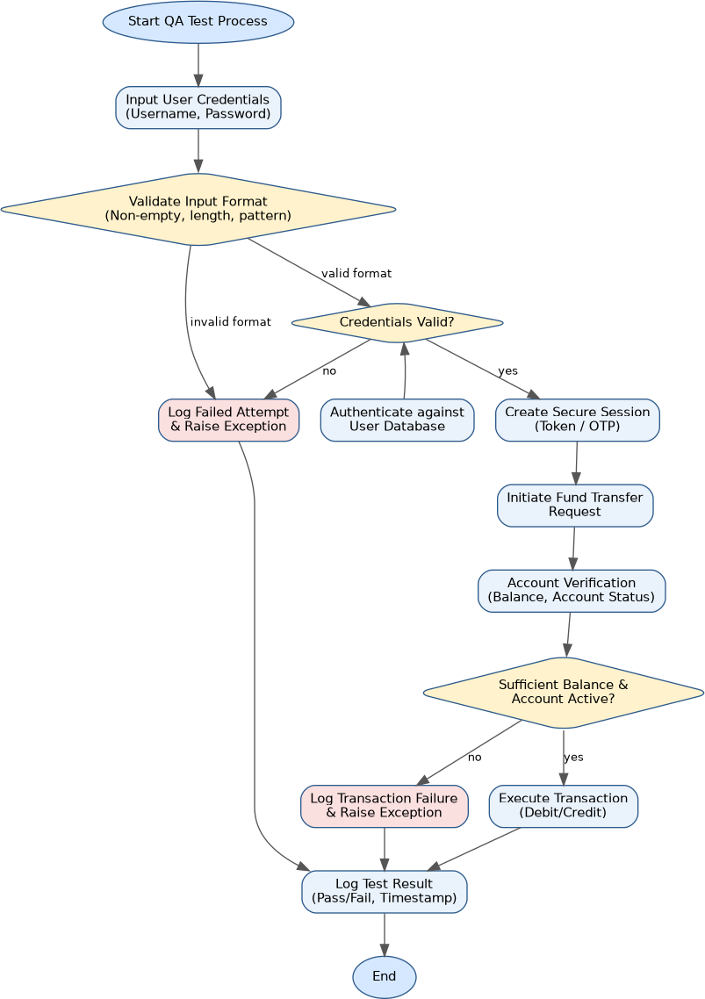
Figure 1: Process flow for Online Banking System testing procedure

Error Identification, Root Cause Analysis & Correction

Error Identified | Root Cause Analysis | Correction & Justification
Missing boundary check on transfer amount (e.g., negative or zero values accepted) | Developer validated only for NULL/empty input and overlooked numeric range constraints during unit design | Add an explicit range check (amount > 0 and amount <= dailyLimit) before the transaction block; unit-test with boundary values (0, -1, MAX_LIMIT+1)
Session token not re-validated before the fund-transfer step, allowing a stale/expired session to initiate a transfer | Session validation was implemented only in the login module and assumed to persist without re-checking at each sensitive operation | Re-verify session validity at the start of every privileged function (defense-in-depth); justified because financial operations must never trust a cached authentication state
No rollback on partial transaction failure (debit succeeds but credit fails) | Debit and credit operations were coded as two independent steps instead of an atomic unit | Wrap debit/credit inside BEGIN_TRANSACTION / COMMIT_TRANSACTION  with ROLLBACK_TRANSACTION  on any exception, guaranteeing ACID consistency
Failed login attempts not rate-limited, exposing the system to brute-force attacks | Root cause is absence of an attempt-counter and lockout policy tied to authentication logic | Introduce MAX_ATTEMPTS with account lockout and exponential back-off, justified by OWASP authentication best practices

Application of OOAD / QA Concepts
  - Encapsulation: authentication, verification, and transfer are separated into independent, cohesive functions with their own responsibility.
  - Exception handling hierarchy models real-world banking failure modes (InputValidationException, AuthenticationException, InsufficientFundsException) instead of one generic error.
  - Transaction integrity (ACID) is applied to the fund-transfer use case to prevent partial updates.
  - Test logging supports traceability and audit requirements typical of quality assurance in regulated financial systems.

Q2. E-Commerce Shopping Platform

Modules / Features: Product Search, Shopping Cart, Payment Gateway
Design pseudocode for a usability testing evaluation that measures customer interaction efficiency, including product search time, checkout completion time, and navigation complexity. Explain how the algorithm collects and analyzes user behaviour data.

Pseudocode
BEGIN Usability_Test_ECommerce

STRUCTURE SessionMetrics:
userId, searchTime, checkoutTime, clickCount, backNavigationCount, errorCount, deviceType
END STRUCTURE

FUNCTION startSession(userId): session = new SessionMetrics(userId)
session.startTime = currentTimestamp() logEvent("SESSION_START", userId) RETURN session
END FUNCTION

// ---- Measure Product Search Efficiency ----FUNCTION measureSearch(session, query):
t1 = currentTimestamp()
results = ProductSearch.execute(query) t2 = currentTimestamp() session.searchTime = t2 - t1
session.searchRelevance = computeRelevanceScore(results, query)
IF results IS EMPTY THEN session.errorCount += 1
logEvent("SEARCH_ZERO_RESULTS", query) END IF
RETURN results END FUNCTION

// ---- Track Navigation Complexity ----FUNCTION trackNavigation(session, pageEvent):
session.clickCount += 1
IF pageEvent.type == "BACK" THEN session.backNavigationCount += 1
END IF
logEvent("NAV", pageEvent) END FUNCTION

// ---- Measure Checkout Completion Time ----

FUNCTION measureCheckout(session, cart): t1 = currentTimestamp()
IF cart IS EMPTY THEN
session.errorCount += 1
RETURN "ABANDONED_EMPTY_CART" END IF
status = PaymentGateway.process(cart) t2 = currentTimestamp() session.checkoutTime = t2 - t1
IF status != "SUCCESS" THEN
session.errorCount += 1 END IF
RETURN status END FUNCTION

// ---- Compute Navigation Complexity Score ----FUNCTION computeComplexityScore(session):
// Weighted formula combining clicks, back-tracks and errors score = (session.clickCount * 0.4) +
(session.backNavigationCount * 1.5) + (session.errorCount * 2.0)
RETURN score END FUNCTION

// ---- Analyze Collected Behaviour Data ----FUNCTION analyzeSession(session):
complexity = computeComplexityScore(session) report = {
searchTime: session.searchTime, checkoutTime: session.checkoutTime, complexityScore: complexity, errorCount: session.errorCount
}
IF session.searchTime > SEARCH_TIME_THRESHOLD OR session.checkoutTime > CHECKOUT_TIME_THRESHOLD OR complexity > COMPLEXITY_THRESHOLD THEN report.verdict = "USABILITY_ISSUE" suggestUXImprovement(report)

ELSE
report.verdict = "PASS" END IF
persistToAnalyticsStore(report) RETURN report

END FUNCTION

// ---- Aggregate across many users for trend analysis ----

FUNCTION aggregateUsabilityTrends(allSessions): avgSearchTime = average(allSessions.searchTime) avgCheckoutTime = average(allSessions.checkoutTime) avgComplexity = average(allSessions.complexityScore)
RETURN buildTrendReport(avgSearchTime, avgCheckoutTime, avgComplexity) END FUNCTION

END Usability_Test_ECommerce

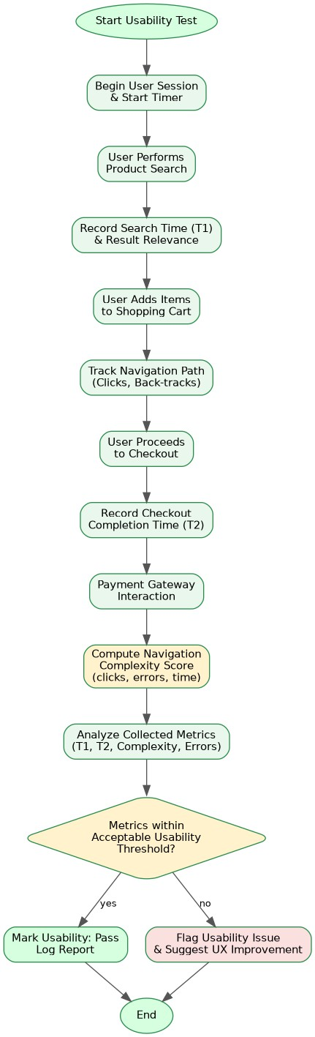
Process Flow Diagram

Figure 2: Process flow for E-Commerce Shopping Platform testing procedure

Error Identification, Root Cause Analysis & Correction

Error Identified | Root Cause Analysis | Correction & Justification
Complexity score formula does not normalize for | The weighting scheme (clicks, back-navigation, | Normalize the score against expected task benchmarks

Error Identified | Root Cause Analysis | Correction & Justification
session length, unfairly penalizing users who legitimately browse longer | errors) was designed without accounting for task type or intended session duration | (e.g., complexity per minute) and justify weights using prior UX research or A/B baseline data
Zero-result searches are logged but not distinguished from slow-but-successful searches when computing the verdict | The analyzeSession function only checks time thresholds and complexity, not search-quality failures | Add a dedicated relevance/failure flag to the verdict logic so zero-result and low-relevance searches are separately reported, giving more actionable UX feedback
Abandoned/empty-cart checkouts are counted as an error but not separated from payment-gateway failures in analytics | Root cause is a single generic errorCount counter used for multiple distinct failure types | Split errorCount into categorized counters (cartAbandonment, paymentFailure, searchFailure) — justified because each requires a different UX fix

Application of OOAD / QA Concepts
  - Behavioural instrumentation pattern: every user action (search, click, checkout) is timestamped and logged for later analysis, a core usability-testing technique.
  - Quantitative UX metrics (search time, checkout time, navigation complexity) are converted into an objective composite score rather than relying on subjective opinion.
  - Threshold-based verdicts operationalize usability heuristics (efficiency, learnability) into automatable pass/fail criteria.
  - Aggregation across sessions supports trend analysis, which is essential for continuous usability improvement in an e-commerce platform.

Q3. Hospital Management System

Modules / Features: Patient Registration, Appointment Scheduling, Medical Records
Write pseudocode to generate and execute test cases for appointment scheduling functionality. Include validation of doctor availability, appointment conflicts, patient information accuracy, and system responses to invalid requests.

Pseudocode
BEGIN TestSuite_AppointmentScheduling

// ---- Test Case Generation ----FUNCTION generateTestCases():
testCases = []
testCases.ADD(TC("TC01", validPatient, validDoctor, futureSlot, EXPECT="CONFIRMED"))
testCases.ADD(TC("TC02", missingPatientId, validDoctor, futureSlot, EXPECT="REJECTED"))
testCases.ADD(TC("TC03", validPatient, validDoctor, pastDateSlot, EXPECT="REJECTED"))
testCases.ADD(TC("TC04", validPatient, unavailableDoctor, busySlot, EXPECT="REJECTED"))
testCases.ADD(TC("TC05", validPatient, validDoctor, doubleBookedSlot, EXPECT="CONFLICT"))
testCases.ADD(TC("TC06", invalidFormatPatientId, validDoctor, futureSlot, EXPECT="REJECTED"))
RETURN testCases END FUNCTION

// ---- Patient Information Accuracy Check ----FUNCTION validatePatientInfo(patient):
IF patient.id IS NULL OR NOT matchesPattern(patient.id, ID_REGEX) THEN RETURN FAIL("Invalid or missing patient ID")

END IF
IF patient.name IS EMPTY OR patient.dob IS INVALID_DATE THEN RETURN FAIL("Incomplete demographic data")

END IF RETURN PASS()
END FUNCTION

// ---- Doctor Availability Check ----
FUNCTION checkDoctorAvailability(doctorId, slot): schedule = DB.getDoctorSchedule(doctorId)
IF schedule IS NULL THEN RETURN FAIL("Doctor not found")

END IF
IF NOT schedule.isWorkingAt(slot) THEN

RETURN FAIL("Doctor unavailable at requested slot") END IF

RETURN PASS() END FUNCTION

// ---- Appointment Conflict Detection ----FUNCTION checkConflict(doctorId, slot):
existingAppointments = DB.getAppointments(doctorId, slot.date) FOR EACH appt IN existingAppointments DO
IF appt.overlaps(slot) THEN
RETURN CONFLICT("Slot already booked: " + appt.id) END IF

END FOR RETURN PASS()
END FUNCTION

// ---- Execute a single test case ----FUNCTION executeTestCase(tc):

TRY
patientResult = validatePatientInfo(tc.patient) IF patientResult.status == "FAIL" THEN
RAISE ValidationException(patientResult.message) END IF

availResult = checkDoctorAvailability(tc.doctorId, tc.slot) IF availResult.status == "FAIL" THEN
RAISE AvailabilityException(availResult.message) END IF

conflictResult = checkConflict(tc.doctorId, tc.slot) IF conflictResult.status == "CONFLICT" THEN
RAISE ConflictException(conflictResult.message) END IF

bookAppointment(tc.patient, tc.doctorId, tc.slot) actual = "CONFIRMED"

CATCH ValidationException, AvailabilityException AS e actual = "REJECTED"
CATCH ConflictException AS e actual = "CONFLICT"

END TRY

passed = (actual == tc.expected) logTestResult(tc.id, tc.expected, actual, passed) RETURN passed

END FUNCTION

// ---- Driver ----FUNCTION runAllTests():
testCases = generateTestCases()
FOR EACH tc IN testCases DO executeTestCase(tc)
END FOR
generateSummaryReport() END FUNCTION

END TestSuite_AppointmentScheduling

Process Flow Diagram
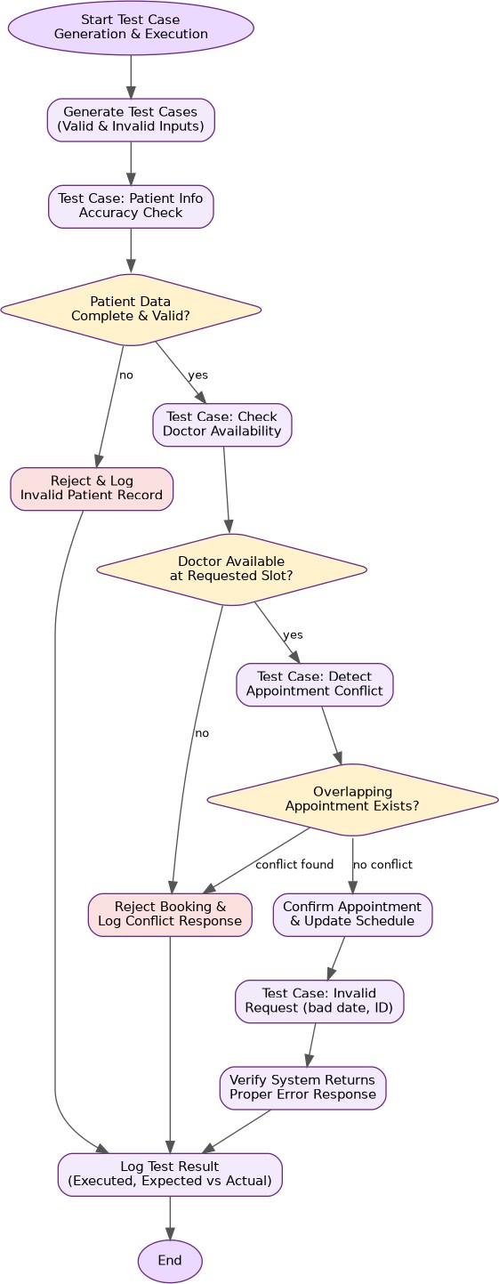

Figure 3: Process flow for Hospital Management System testing procedure

Error Identification, Root Cause Analysis & Correction

Error Identified | Root Cause Analysis | Correction & Justification
Past-date appointment slots are not explicitly rejected before reaching the availability check | Doctor-availability logic assumes only future dates are ever passed in, so no separate date-sanity check exists | Add an explicit guard (slot.date  >= today) at the start of executeTestCase and raise a distinct ValidationException; justified because it fails fast and gives a clearer error message than an availability mismatch
Conflict detection only checks the requested doctor's schedule, not whether the same patient already has an overlapping appointment with a different doctor | checkConflict was scoped narrowly to doctor-side double-booking during design, overlooking patient-side conflicts | Add a parallel checkPatientConflict(patientId, slot) call so both sides of the booking are validated, improving correctness of the scheduling module
Invalid patient-ID format test case (TC06) and missing-ID test case (TC02) both map to the same generic REJECTED outcome, hiding which validation rule actually failed | validatePatientInfo returns a single FAIL status without an error code distinguishing the specific rule violated | Introduce distinct error codes/messages per validation rule so test logs and QA reports can pinpoint exact root causes instead of a generic rejection

Application of OOAD / QA Concepts
  - Test-case design uses equivalence partitioning and boundary-value analysis (valid slot, past date, double-booked slot, invalid ID) to maximize defect coverage with a minimal test set.
  - Layered validation (patient info -> doctor availability -> conflict check) mirrors good object-oriented separation of concerns across independent modules.
  - Exception-driven control flow maps each failure category to a distinct, traceable exception type instead of a single catch-all error.
  - Expected-vs-actual comparison in executeTestCase implements the core QA principle of automated pass/fail verification.

Q4. Airline Reservation System

Modules / Features: Passenger Registration, Flight Booking, Seat Allocation
Develop pseudocode for a constraint-based testing approach where booking requests must satisfy conditions such as valid passenger information, seat availability, and payment confirmation. Show how invalid booking scenarios are detected and handled.

Pseudocode
BEGIN Constraint_Based_Test_AirlineBooking

STRUCTURE BookingRequest:
passenger, flightId, seatPreference, paymentInfo END STRUCTURE

// ---- Constraint Definitions ----CONSTRAINTS = [
C1: "Passenger info must be complete and valid", C2: "Requested seat must be available on the flight", C3: "Payment must be confirmed before seat lock"
]

FUNCTION validatePassenger(passenger):
IF passenger.name IS EMPTY OR passenger.passportId IS INVALID THEN RETURN FAIL("C1 violated: invalid passenger information")

END IF
IF passenger.age < 0 OR passenger.age > 120 THEN RETURN FAIL("C1 violated: implausible age value")

END IF RETURN PASS()
END FUNCTION

FUNCTION checkSeatAvailability(flightId, seatPref): flight = DB.getFlight(flightId)
IF flight IS NULL THEN
RETURN FAIL("C2 violated: flight does not exist") END IF
availableSeats = flight.getAvailableSeats(seatPref.class) IF availableSeats.count == 0 THEN
RETURN FAIL("C2 violated: no seats available in requested class") END IF
RETURN PASS(availableSeats.first()) END FUNCTION

FUNCTION confirmPayment(paymentInfo, amount):
IF paymentInfo IS NULL OR paymentInfo.cardValid == FALSE THEN RETURN FAIL("C3 violated: invalid payment details")

END IF
status = PaymentGateway.charge(paymentInfo, amount) IF status != "SUCCESS" THEN
RETURN FAIL("C3 violated: payment not confirmed") END IF

RETURN PASS() END FUNCTION

// ---- Constraint-Based Booking Evaluation ----FUNCTION processBooking(request):

TRY
r1 = validatePassenger(request.passenger)
IF r1.status == "FAIL" THEN RAISE ConstraintException(r1.message) END IF

r2 = checkSeatAvailability(request.flightId, request.seatPreference)
IF r2.status == "FAIL" THEN RAISE ConstraintException(r2.message) END IF seat = r2.data

// Temporarily hold the seat before payment to prevent race conditions holdSeat(seat, request.passenger, HOLD_DURATION)

r3 = confirmPayment(request.paymentInfo, seat.price)
IF r3.status == "FAIL" THEN releaseSeatHold(seat)
RAISE ConstraintException(r3.message) END IF

allocateSeat(seat, request.passenger) bookingId = generateBookingId()
logTestResult(bookingId, "CONFIRMED", currentTimestamp()) RETURN CONFIRMED(bookingId)

CATCH ConstraintException AS e
logTestResult(request, "REJECTED - " + e.message, currentTimestamp()) RETURN REJECTED(e.message)

END TRY END FUNCTION

// ---- Constraint Test-Case Matrix ----FUNCTION runConstraintTests():
scenarios = [
("Valid all constraints", validPassenger, availableSeat, validPayment, EXPECT="CONFIRMED"),
("Invalid passenger", badPassenger, availableSeat, validPayment, EXPECT="REJECTED:C1"),

("No
seats
left",
validPassenger,
fullFlight,
validPayment,
EXPECT="REJECTED:C2"),
("Payment declined", validPassenger, availableSeat, badPayment, EXPECT="REJECTED:C3")
]
FOR EACH s IN scenarios DO
actual = processBooking(buildRequest(s)) compareAndLog(s.EXPECT, actual)
END FOR END FUNCTION

END Constraint_Based_Test_AirlineBooking

Process Flow Diagram
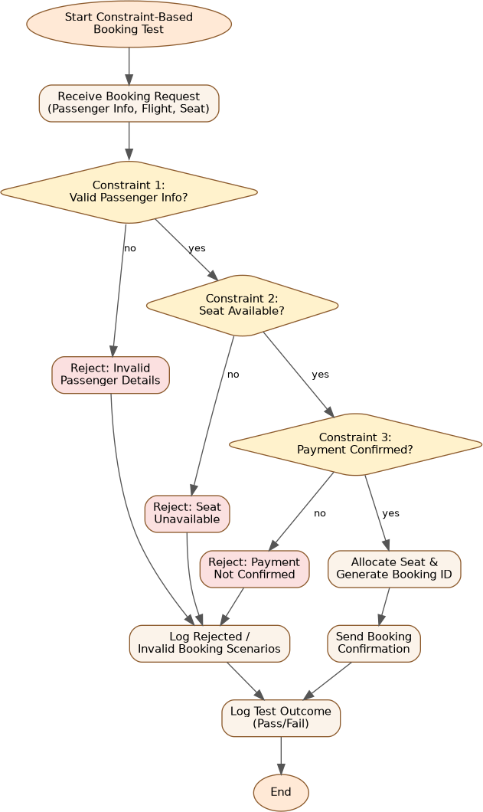

Figure 4: Process flow for Airline Reservation System testing procedure

Error Identification, Root Cause Analysis & Correction

Error Identified | Root Cause Analysis | Correction & Justification
Seat hold is placed before payment confirmation, but there is no timeout-expiry test to verify the hold is released if payment stalls indefinitely | holdSeat introduces a HOLD_DURATION  constraint that was never exercised by a dedicated test scenario | Add a constraint test case that simulates a payment delay beyond HOLD_DURATION and asserts the seat is auto-released, preventing permanently locked inventory
Age validation (0-120) is a weak proxy for real passport/date-of-birth validation and can silently pass malformed data | The check substitutes a plausibility range for genuine cross-validation against passportId and date-of-birth format | Cross-validate age against passenger.dateOfBirth using a proper date parser rather than an isolated numeric range, closing the gap between the two data points
Constraint violation messages (C1/C2/C3) are logged only as free text, making automated  regression comparison brittle | Root cause is embedding the constraint identifier inside a human-readable string instead of a structured error code | Return a structured  {constraintId, message} object from each validator so downstream comparison (compareAndLog) is exact-match reliable, not string-matching dependent

Application of OOAD / QA Concepts
  - Constraint-based testing explicitly enumerates each business rule (C1, C2, C3) and derives dedicated test scenarios, ensuring traceability from requirement to test case.
  - Seat holding demonstrates concurrency-aware design — a key OOAD consideration to prevent race conditions when multiple passengers compete for the same seat.
  - Each constraint maps to its own exception and validator function, following the single-responsibility principle.
  - The expected-vs-actual scenario matrix operationalizes systematic, repeatable regression testing for booking logic.

Q5. Smart Library Management System

Modules / Features: Book Search, Book Reservation, Borrow/Return Services
Write pseudocode for integrating quality assurance and usability testing where the system evaluates both functional correctness (reservation and borrowing operations) and user experience factors such as response time, ease of navigation, and accessibility.

Pseudocode
BEGIN Integrated_QA_Usability_Test_Library

// ---- FUNCTIONAL TEST: Book Search ----
FUNCTION testBookSearch(query): t1 = currentTimestamp()
results = BookSearch.execute(query) t2 = currentTimestamp() responseTime = t2 - t1
correctness = validateSearchResults(results, query)
IF NOT correctness THEN
logDefect("BookSearch", "Incorrect or irrelevant results for: " + query) END IF
RETURN {results, responseTime, correctness} END FUNCTION

// ---- FUNCTIONAL TEST: Book Reservation (no double-booking) ----FUNCTION testReservation(userId, bookId):

TRY
book = DB.getBook(bookId) IF book IS NULL THEN
RAISE ValidationException("Book not found") END IF
IF book.status == "RESERVED" AND book.reservedBy != userId THEN RAISE ConflictException("Book already reserved by another user")

END IF
reserveBook(book, userId)
logTestResult("Reservation", bookId, "PASS", currentTimestamp()) RETURN "RESERVED"
CATCH ValidationException, ConflictException AS e logDefect("Reservation", e.message)

RETURN "FAILED" END TRY
END FUNCTION

// ---- FUNCTIONAL TEST: Borrow / Return ----FUNCTION testBorrowReturn(userId, bookId, action):

TRY
book = DB.getBook(bookId)

IF action == "BORROW" THEN
IF book.copiesAvailable <= 0 THEN
RAISE ValidationException("No copies available") END IF
decrementCopies(book)
setDueDate(userId, book, DEFAULT_LOAN_PERIOD)
ELSE IF action == "RETURN" THEN
fine = calculateFine(userId, book) incrementCopies(book) closeLoanRecord(userId, book, fine)

END IF
logTestResult("BorrowReturn", bookId + ":" + action, "PASS", currentTimestamp())
CATCH ValidationException AS e logDefect("BorrowReturn", e.message)

END TRY END FUNCTION

// ---- USABILITY TEST: Response Time, Navigation, Accessibility ----FUNCTION testUsability(session):
metrics = {}
metrics.avgResponseTime = average(session.actionResponseTimes) metrics.clicksToReserve = session.countClicksFor("RESERVE_FLOW") metrics.accessibilityScore = runAccessibilityAudit(session.pageDOM)
// e.g. screen-reader labels, contrast ratio, keyboard navigation RETURN metrics

END FUNCTION

// ---- INTEGRATION: Combine Functional + Usability Results ----FUNCTION runIntegratedTestSuite(userId, bookId, query, session):
searchResult = testBookSearch(query) reservationResult = testReservation(userId, bookId)
borrowResult = testBorrowReturn(userId, bookId, "BORROW") usabilityMetrics = testUsability(session)

report = { functional: {
search: searchResult.correctness, reservation: reservationResult, borrow: borrowResult
},
usability: usabilityMetrics
}

IF usabilityMetrics.avgResponseTime > RESPONSE_TIME_THRESHOLD OR usabilityMetrics.accessibilityScore < ACCESSIBILITY_MIN_SCORE THEN report.usabilityVerdict = "NEEDS_IMPROVEMENT"

ELSE
report.usabilityVerdict = "ACCEPTABLE" END IF

generateConsolidatedReport(report) RETURN report
END FUNCTION

END Integrated_QA_Usability_Test_Library

Process Flow Diagram
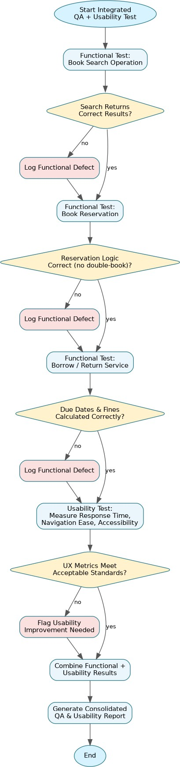
Figure 5: Process flow for Smart Library Management System testing procedure

Error Identification, Root Cause Analysis & Correction

Error Identified | Root Cause Analysis | Correction & Justification
Reservation conflict check only compares reservedBy to the current user but ignores books that are already fully on loan (copiesAvailable == 0) with no copies left to reserve against | testReservation was designed around the RESERVED status flag only, not the broader availability state shared with the borrow module | Check book.copiesAvailable and reservation queue state together before confirming a reservation, so functional correctness covers both reservation and inventory logic consistently
Accessibility is reduced to a single numeric accessibilityScore, which can mask specific failing criteria (e.g., missing alt-text vs. poor contrast) | runAccessibilityAudit was treated as a black-box score rather than itemized against WCAG success criteria | Return a breakdown of individual accessibility checks alongside the aggregate score, justified because a single number hides which usability defect needs fixing
Fine calculation on RETURN is invoked without first validating that a loan record actually exists for that user/book pair | closeLoanRecord assumes testBorrowReturn is always called in the correct BORROW-then-RETURN  sequence | Add an explicit loan-existence check before  calculateFine/closeLoanRecord and raise a ValidationException otherwise, preventing crashes from out-of-sequence test calls

Application of OOAD / QA Concepts
  - Demonstrates integrated QA: functional correctness (search, reservation, borrow/return) and non-functional usability (response time, accessibility) are tested within a single consolidated suite, reflecting real-world quality assurance practice.
  - Accessibility auditing operationalizes WCAG-style usability criteria into an automatable check, extending usability testing beyond speed/navigation metrics.
  - State-conflict handling (double reservation, no available copies) reflects careful object state modeling in OOAD.
  - The consolidated report pattern supports holistic decision-making, combining defect counts with UX verdicts for release readiness.

